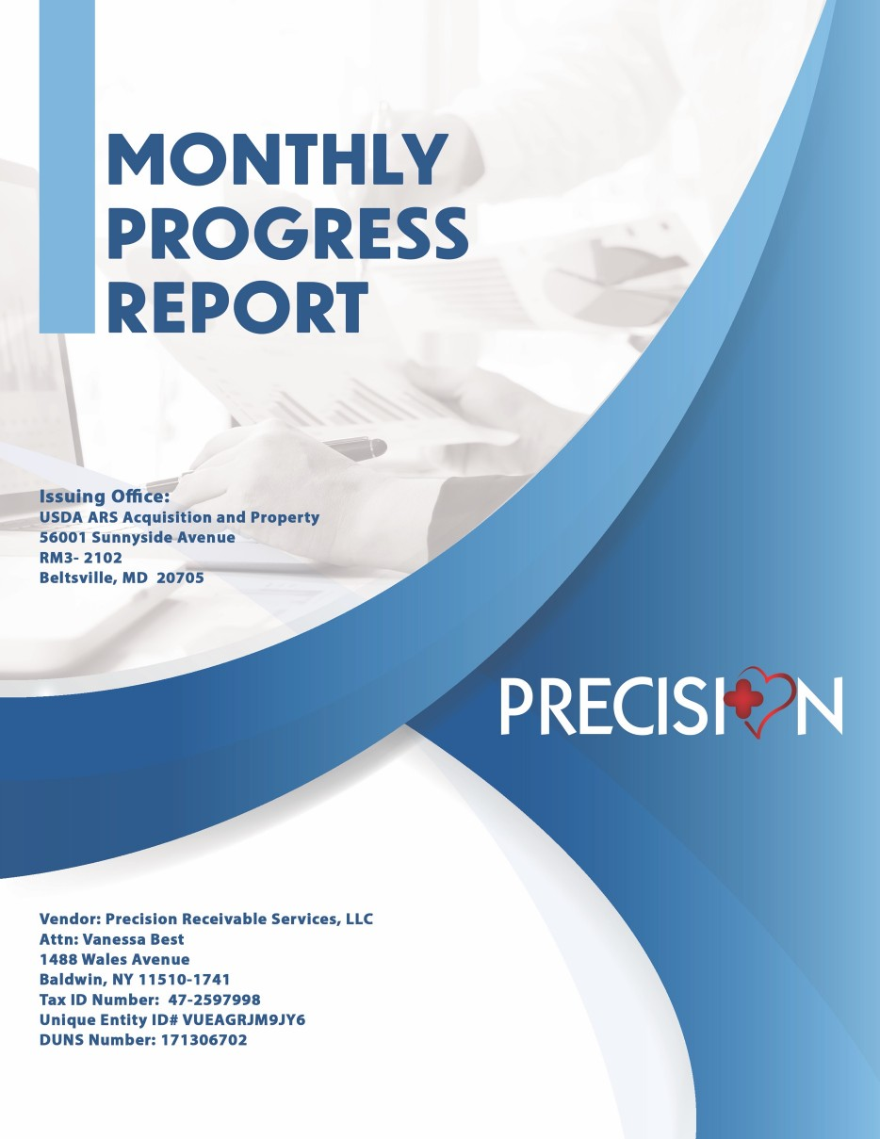

APRIL 2024

### Contract # 11316023P0003NCD

**ISSUED BY:**

**OAS**

**725 17th St. NW Room 5200**

**WASHINGTON DC 20503**

**DELIVER TO: NCD (SSDMD/RDS):**

**JOINT BASE ANACOSTIA-BOLLING (JBAB)**

**BLDG 410, DOOR 123**

**WASHINGTON DC 20509**

#### DATES COVERED BY THIS REPORT:

#### 4/1/24 –4/30/24

**Submitted May 12, 2024**

1. **Scope of Work:**

Under this Agreement, contractors shall provide Personal Assistance Services (PAS) to

support the Office of the National Cyber Director (ONCD), Office of

the General Counsel (OGC) in providing its employees assistance with performing

activities of daily living that their employees otherwise perform if they did not have a disability

and that’s “not otherwise required as a reasonable accommodation” as required by

section 501 of the Rehabilitation Act of 1973. The Government shall not exercise any

supervision or control over the order’s service providers performing the services herein.

Contractor’s service providers shall be accountable solely to the Contractor who, in turn is

responsible to the Government.

The Office of the National Cyber Director (ONCD) is a component of the Executive Office of the

President, led by the National Cyber Director, the principal advisor to the President of the United

States on cybersecurity. ONCD has substantial statutory requirements to oversee the development

of policy regarding cybersecurity and oversee implementation of policies and programs to improve

the U.S. cybersecurity posture. ONCD comprises of five divisions; moreover, ONCD maintains a

front office with traditional organizational support functions and immediate support staff for the

National Cyber Director and Principal Deputy National Cyber Director. ONCD requires

personal assistance services PAS support that provides non-medical and non-work task

personal assistance for an employee with a targeted disability so that said employee will be

able to perform the essential functions of their job, without posing a direct threat to safety once

the PAS support is provided. The PAS support provided will help the ONCD employee

accomplish their mission.

# **PLACE OF PERFORMANCE (S)**

The initial primary place of performance will be the White House Campus.

## **STATUS (Completed, ongoing, or not yet begun):**

We are providing ongoing performance on this Contract.

## **Deliverables / Schedule:**

For the month of April 2024 – Precision commenced services on April 1st 2024. Primary PAS attendant continued government security clearance process.

## Key Deliverables

|  |  |  |  |
| --- | --- | --- | --- |
| ***Item No.*** | ***Deliverable- PAS Services in Washington DC*** | ***Objective*** | ***Date Range*** |
| 1 | PAS Assistance Scheduled and provided in APRIL 2024 for employee work location at White House Campus. | Provide PAS Services  to ONCD federal employee. | April 1st 2024 thru April 30th 2024 |
|  | PAS Hours = 18 |  | 18 (PAS) + 18 (Backup)= |
|  | PAS Backup Hours = 18 |  | 36 Hours |
|  | Total Hours= 36 |  |  |
|  | *Backup = first 2 Hours per shift (9 shifts) |  |  |
|  |  |  |  |
|  |  |  |  |

#### Specific Tasks Accomplished:

* Providing mobility support
* Facilitating meal preparation
* Assisting with personal hygiene
* Support document management activities
* Miscellaneous activities

## Contractor’s Key Personnel:

|  |  |  |  |
| --- | --- | --- | --- |
| S/No | Project Role | Personnel | LOE/Hours |
| 1 | Personal Assistant | Lawrence Frazier | 18 |
| 2 | Personal Assistant Back-up | Kevin Johnson | 18 |
| 3 | Program Management | Vanessa Best | 32 |
| 4 | Program Administration | Elyce Lloyd | 32 |

# PROBLEMS ENCOUNTERED:

No problems were encountered.

# DAYS/TIMESHEET

|  |  |  |  |  |
| --- | --- | --- | --- | --- |
| **DAY OF SERVICE** | **DATE OF SERVICE PROVIDED** | **SHIFT START** | **SHIFT END** | **HOURS** |
| Monday | 4/1/24 | 9:00am | 11:00am | 2 |
| Tuesday | 4/2/24 |  |  | 0 |
| Wednesday | 4/3/24 | 9:00am | 11:00am | 2 |
| Thursday | 4/4/24 |  |  | 0 |
| Friday | 4/5/24 |  |  | 0 |
| Monday | 4/8/24 | 9:00am | 11:00am | 2 |
| Tuesday | 4/9/24 |  |  | 0 |
| Wednesday | 4/10/24 | 9:00am | 11:00am | 2 |
| Thursday | 4/11/24 |  |  | 0 |
| Friday | 4/12/24 |  |  | 0 |
| Monday | 4/15/24 | 9:00am | 11:00am | 2 |
| Tuesday | 4/16/24 |  |  | 0 |
| Wednesday | 4/17/24 | 9:00am | 11:00am | 2 |
| Thursday | 4/18/24 |  |  | 0 |
| Friday | 4/19/24 |  |  | 0 |
| Monday | 4/22/24 | 9:00am | 11:00am | 2 |
| Tuesday | 4/23/24 |  |  | 0 |
| Wednesday | 4/24/24 | 9:00am | 11:00am | 2 |
| Thursday | 4/25/24 |  |  | 0 |
| Friday | 4/26/24 |  |  | 0 |
| Monday | 4/29/24 | 9:00am | 11:00am | 2 |
|  |  |  |  |  |
|  |  |  | **Total Regular Hours:** | **18** |  |
|  |  |  | **Back-up Hours:** | **18** |  |
|  |  |  | **Grand TOTAL** | **36** |  |

|  |  |
| --- | --- |
| **LABOR**  **CATEGORY** | **HOURS** |
| PAS | 18 |
| PAS-BACKUP | 18 |
| PROGRAM MANAGEMENT | 32 |
| ADMINISTRATIVE SUPPORT | 32 |
| **Total Labor**  **Hours** | **100** |

8.0 Invoicing and Funding

Base Period: 9/14/2023 – 9/13/2024

Funding $224,134.08

|  |  |  |  |  |  |  |
| --- | --- | --- | --- | --- | --- | --- |
| Service Period | Invoice Number | Labor  Hours | Amount Claimed - Current Period | Amount Remaining | Total Amount Claimed | Percentage Utilized |
| Jun-23 | 3064 | 131 | $9,267.19 | $104,012.81 | $9,267.19 | 8% |
| Jul-23 | 3091 | 230 | $16,239.02 | $87,773.79 | $25,506.21 | 22% |
| Aug 2023 | 3111 | 294 | $20,829.74 | $66,944.05 | $46,335.95 | 41% |
| Sep-23 | 3132 | 264 | $18,677.84 | $48,266.21 | $65,013.79 | 68% |
| With Additional Funding* | 3132 | 264 | $18,677.84 | $159,120.29 |  |  |
| Sep-23 | 3205 | 264 | $18,677.84 | $121,047.31 |  | 46% |
| Oct-23 | 3147 | 274 | $19,395.14 | $139,725.15 | $84,408.93 | 38% |
| Nov-23 | 3205 | 264 | $18,677.84 | $121,047.31 | $103,086.77 | 46% |
| Dec-23 | 3206 | 174 | $12,222.14 | $108,825.17 | $115,308.91 | 51% |
| Jan-24 | 3226 | 241.5 | $17,063.92 | $91,761.25 | $132,372.83 | 59% |
| Feb-24 | 3261 | 264 | $18,677.84 | $73,083.41 | $151,050.67 | 67% |
| 24-Mar | 3271 | 107.75 | 7470.03 | $65,613.38 | $158,520.70 | 71% |
| 24-Apr | 3298 | 100 | 6,914.12 | $58,699.26 | $165,434.82 | 74% |